Eucalyptus Regeneration

**Introduction**

Common agricultural practices are well understood to have devastating effects on

This study includes data from

The data contains

351 samples from 18 sites (properties)

Each quadrat 15mx15m and a minimum of 60m from eucalyptus canopy

Between 4 and 11 quadrats per property per survey, new random quadrats each time

3 surveys, new quadrats sampled each time (winter, spring, autumn)

Winter (July) 2006, Spring (October-December) 2006, Autumn (April-May) 2007

– missing August-September 2006 and January-March 2007

The goal of this analysis is to determine factors that contribute to eucalyptus canopy regeneration

We hypothesize that

total seedlings ~ property, landscape, PET, precipitation, canopy, distance to canopy

**Methods**

Hypothesis testing approach because data has 38 parameters

We first analyzed the data for imbalances and relationships,

Properties vary in sizes but number of quadrats appear normally distributed with an average of 6.5 quadrats per property

Since the response variable is count data we started with a Poisson model and detected overdispersion

The final model was tested by adding and removing variables and random effect of property

The formula for our model with the most explanatory power is:

total eucalyptus seedlings ~ estimated uranium concentration (ppm) + distance to eucalyptus canopy (m) + bare ground cover + landscape position + property

**Results**

261/351 (74.4%) no seedlings, 90/351 (25.6%) contain seedlings

271/351 (77.2%) no canopy, 80/351 (22.8%) with some canopy cover

Seedling count: 0-50cm: 230 50cm-2m: 380 >2m: 40 total: 650

The mean number of seedlings per property was 36.11 ± 40.14 (standard deviation) seedlings however the mean number of seedlings per sampled quadrat was only 1.85 ± 6.20 (standard deviation) seedlings per quadrat, as many quadrats (261/351) contained 0 seedlings.

Landscape count: crest: 12 flat: 100 slope: 228 toe_of_slope: 11

Seedlings by landscape: crest: 4 flat: 124 slope: 499 toe_of_slope: 23

The parameter estimates

**Conclusion**

The greatest predictor of

Future analysis could improve by including time since grazing stopped and keeping quadrats constant to monitor growth and survival over time.

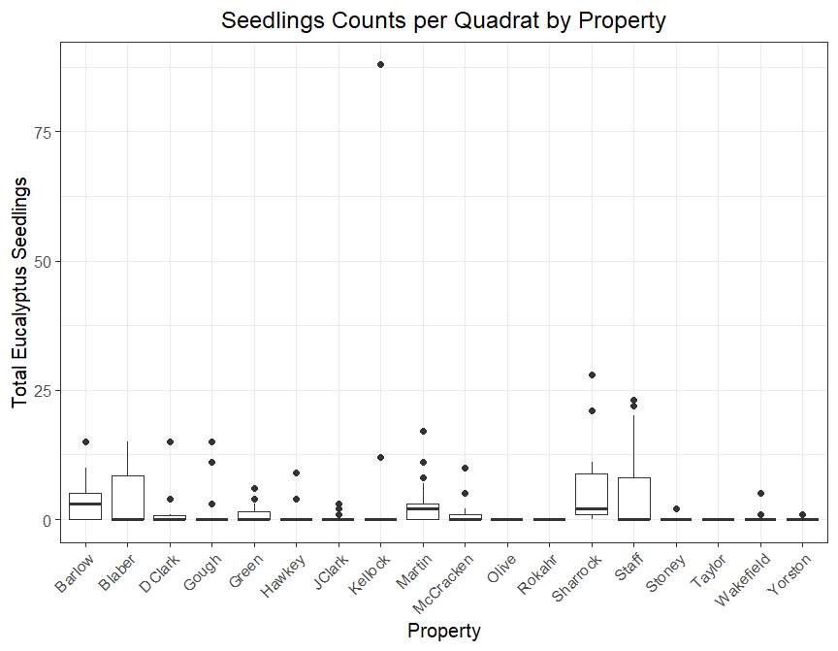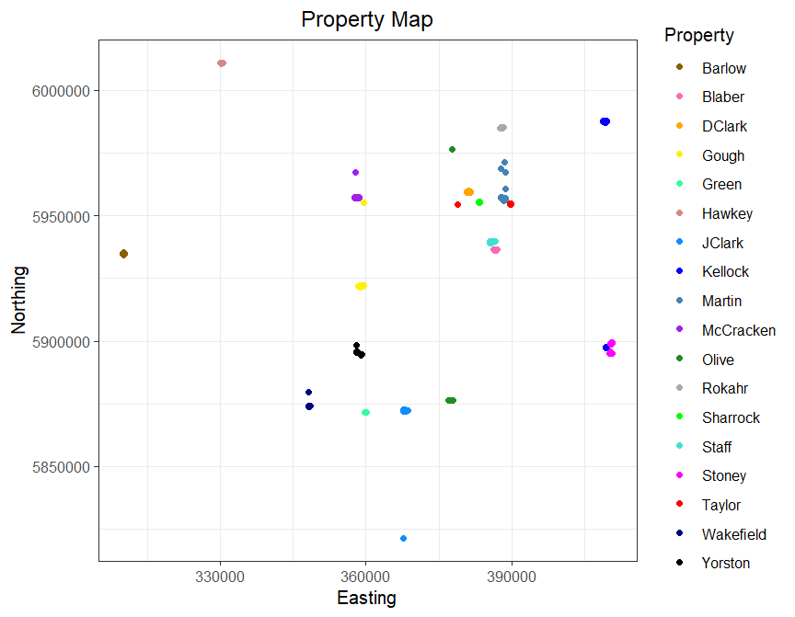Appendix

Seedling count varies greatly among properties. Median seedling count for all but 3 properties is 0. Barlow has the highest median seedling count = 3. Sharrock has the highest mean seedling count = 6.75

Spatial distribution of properties. Some properties have more distantly scattered quadrats.

**Figure 2.**

**Figure 1.**

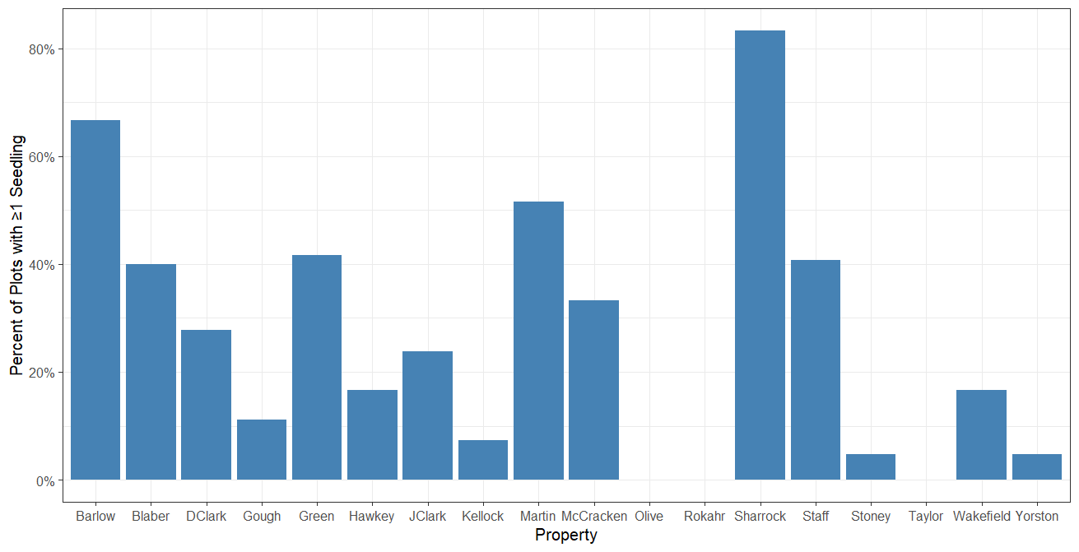

**Figure 3. Percentage of plots with non-zero seedling counts by property**

Presence of seedlings varies greatly among properties. 3 properties- Olive, Rokahr, and Taylor had no seedlings in any plots

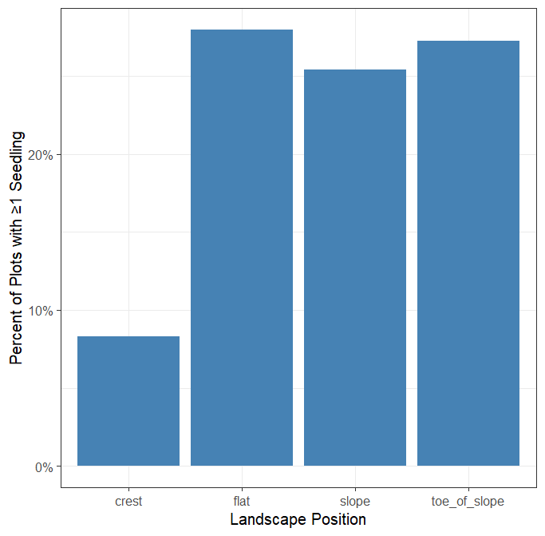

Overall low proportion of all plots contain seedlings. Fewer crest plots contain seedlings than other landscapes however this can potentially be explained by small sample size.

**Figure 4. Percentage of plots with non-zero seedling counts by landscape**

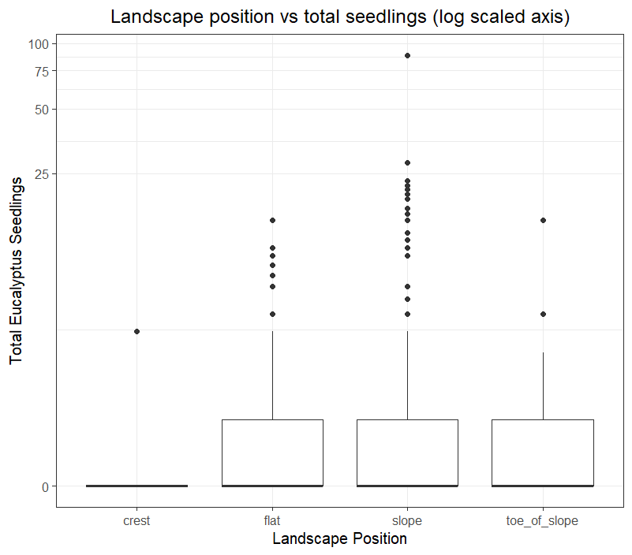

Landscape position weakly affects seedling count. Slope most represented and has highest range. Y-axis log scaled to better display depression effect of the near zero means caused by overrepresentation of zero seedling counts.

**Figure 5.**

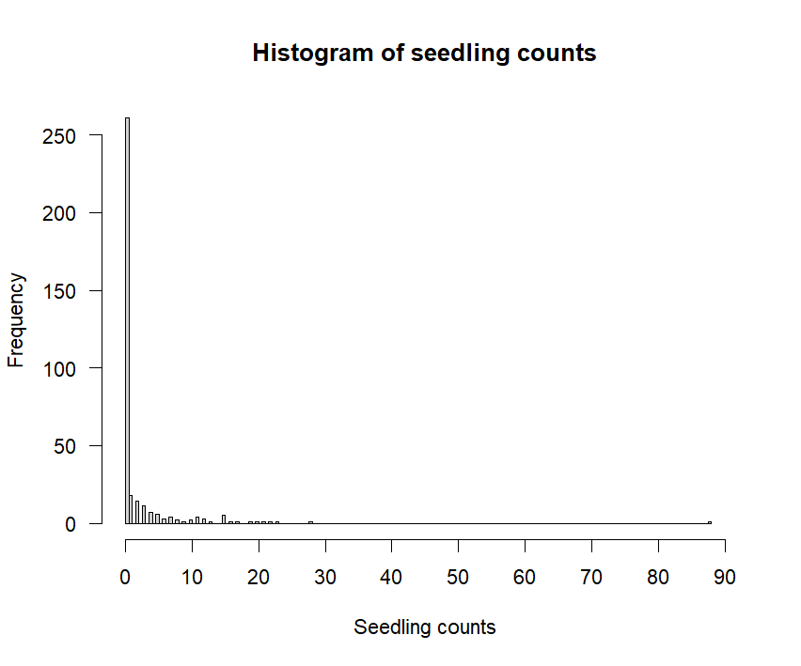

**Figure 6.**

Seedling count data is overdispersed. Seedling count is total seedling count

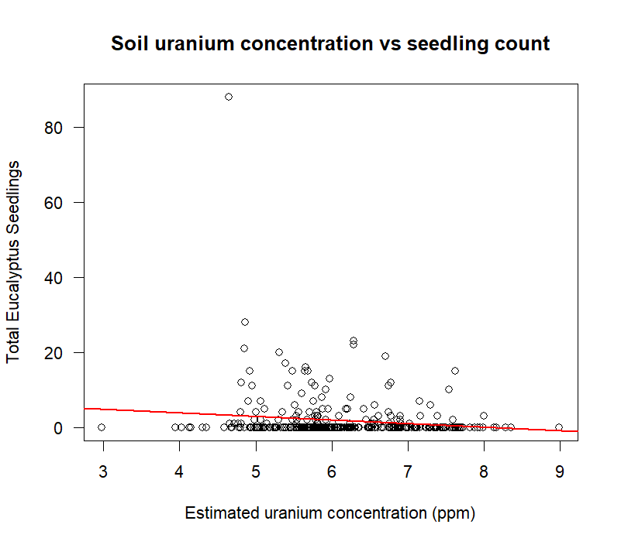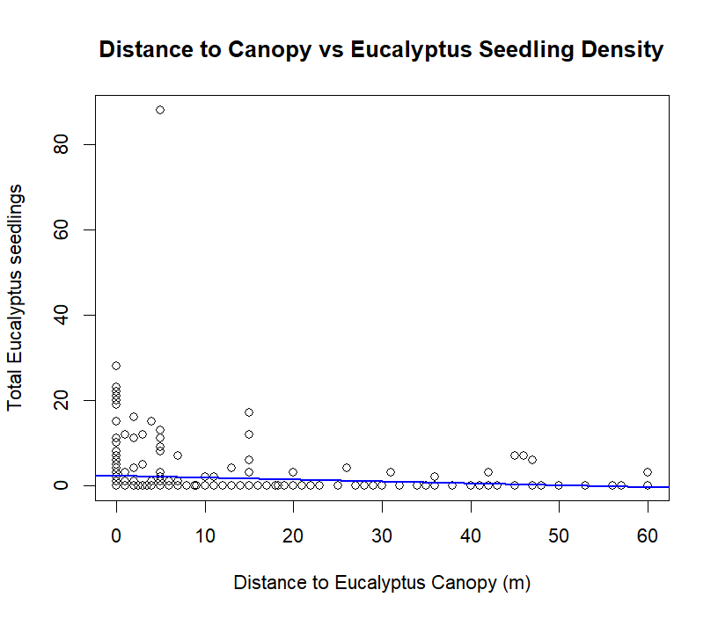

**Figure 8.**

Seedling count decreases with increasing soil uranium concentration

β=-0.9695 seedlings/ppm

Seedling count decreases with distance from existing canopy β=-0.0448 seedlings/m

**Figure 7.**

|  |  |  |  |  |
| --- | --- | --- | --- | --- |
| **Table 1. Negative Binomial GLM summary** | | | | |
| **Formula:** total eucalyptus seedlings ~ estimated uranium concentration (ppm) + distance to eucalyptus canopy (m) + bare ground cover + landscape position + property | | | | |
| **Effects** | **Estimate** | **Std. Error** | **% variance**  **explained** | **P value** |
| (Intercept) | 1.638 | 1.1919 |  | 0.38036 |
| Uranium (ppm) | 46.56103 | 16.1014 | 3.045117 | 0.3143 |
| Distance to canopy (m) | 24.94619 | 9.23005 | 6.354969 | 0.0309 |
| Bare ground cover | 39.86516 | 16.6723 | 4.854418 | 0.0273 |
| Landscape position |  |  | 4.303081 |  |
| *Crest (reference)* | *0* | *0* | *0* | *0* |
| Flat | 2.789 | 1.285 |  | 0.02996 |
| Slope | 2.421 | 1.174 |  | 0.03918 |
| Toe of Slope | 3.279 | 1.382 |  | 0.01764 |
| Property |  |  | 75.211966 |  |
| *Barlow (reference)* | *0* | *0* | *0* | *0* |
| Blaber | -0.3541 | 0.8529 |  | 0.67803 |
| DClark | -1.628 | 0.9015 |  | 0.07088 |
| Gough | -1.437 | 0.7985 |  | 0.07191 |
| Green | -1.256 | 0.9134 |  | 0.16915 |
| Hawkey | -2.206 | 0.9876 |  | 0.02548 |
| JClark | -2.510 | 0.8609 |  | 0.00355 |
| Kellock | -0.9651 | 0.7796 |  | 0.21572 |
| Martin | -0.2901 | 0.7067 |  | 0.68139 |
| McCracken | -2.046 | 0.8195 |  | 0.01255 |
| Olive | -62.48 | 1.733e+07 |  | 1.00000 |
| Rokahr | -63.34 | 1.501e+07 |  | 1.00000 |
| Sharrock | -0.7884 | 0.9109 |  | 0.38675 |
| Staff | 0.2350 | 0.7346 |  | 0.74902 |
| Stoney | -2.788 | 1.025 |  | 0.00655 |
| Taylor | -64.13 | 1.733e+07 |  | 1.00000 |
| Wakefield | -2.739 | 1.057 |  | 0.00956 |
| Yorston | -3.812 | 1.296 |  | 0.00328 |
|  |  |  |  |  |

Estimates of negative binomial generalized linear model where estimates are the regression coefficient (β) or the slope on the effect: total eucalyptus seedlings, given by the sum of all eucalyptus counts for each quadrat sample. Reference levels for categorical variables are arbitrarily assigned- landscape position is set relative to “crest” and property is set relative to “Barlow”. Percent variance explained is given by the difference in pseudo R2 with the removal of the given effect. Sample size n = 351.

|  |  |  |  |  |
| --- | --- | --- | --- | --- |
| **Table 2. Analysis of Deviance (ANODEV)** | | | |  |
| **Effects** | **Deviance** | **Residual DF** | **Residual Deviance** | **P value** |
| Null |  | 345 | 328.21 |  |
| Uranium (ppm) | 15.604 | 344 | 312.61 | 7.81e-5 |
| Distance to canopy (m) | 8.819 | 343 | 303.79 | 0.0030 |
| Bare ground cover | 6.027 | 342 | 297.76 | 0.0141 |
| Landscape position | 7.420 | 339 | 290.34 | 0.0596 |
| Property | 101.029 | 322 | 189.32 | 5.73e-14 |

Analysis of deviance table to test negative binomial model fit. Residual DF is Residual degrees of freedom. P value from Chi-Square test.

Code can be found in Github repository linked below:

<https://github.com/mtindall69/bios14/tree/eucalyptus-reexam>